**COMPANY PROFILE**

Table of Contents

**1.** About TZY ENGINEERING PLC 1

2. Core values 1

3. Mission 2

4. Vision 2

5. What we do 2

1.1. Electrical work: 2

5.2. Electromechanical work: 3

6. Objectives 4

6.1. For individual (owners) 4

6.2. For society and government 4

7. Completed and work on progress of the company 5

7.1. Completed work 5

7.2. Current progress of the company 6

8. COMPANY STRUCTURE 7

9. STAFF LIST OF THE COMPANY 8

1. WORK EXPERIENCE OWNER OF THE COMPANY 9

10.1. TEKLAY HAILE (General Manager) 9

10.2. ZEKARIAS DAMTEW (Technical Manager) 9

10.3. YOHANNES TOLOSSA (Finance Manager) 9

11. Document and Recommendation paper of the company 10

1. About TZY ENGINEERING PLC

TZY Electromechanical and Electrical work contractor were established in 2006 E.C under Ethiopian commercial registration and business license. Proc no k/k AA/14/667/691555/2009 by Ethiopian nationals.

This company founded in Ethiopia by three Electrical Engineers, Those are TEKLAY HAILE, ZEKARIAS DAMTEW and YOHANNES TOLOSSA. All of them have good knowledge and experience on electrical and electromechanical works for instance in power concern works, Telecom project, building electrical installation and design, on different electromechanical works like Air conditioning installation, solar energy, pipe works, structure etc. Our purpose is to be leader in the electromechanical and electrical works by providing enhanced services relationship, profitability and turn knowledge in to value for benefit of our clients, government and people. Our company aims to provide client interest and keep loss of power EEPCO.

Our value determine how we behave, with client and each other, They define what we stand for and how we presume our activities helping us to work together in the most effective and fulfilling way. This enables us to create a strong organization culture constantly throughout the network.

We believe in the value of relationship and we plan to see client relationship like partnership and truly believe that our success is result of your success.

# Core values



* Integrity
* Quality of workmanship
* Reliability
* Innovate thinking
* Transparency and honest
* Continuous improvement.

# Mission



* With our strong technical and project management

Delivery team, we will exceed our client Expectation

Quality and reliability.

* To build up modern or advanced services
* Arranging for short, medium and long term plan

action and implementation.

* To build long term relationship with our customers.
* To utilize new and appropriate technology and

Machinery Construction of electromechanical and electrical work.

* Company exists to provide fast, reliable technology assistance to local business

# Vision



* To have highly technically oriented and manage

Mental staff.

* To provide quality services that exceeds the

Expectations Of our esteemed customers.

* To be recognized as the industry leader in quality

Services And Project management in power sector.

# What we do

Our company offers a wide range of service to our clients. We have listed below the services that we offer to our clients along with a brief description.

## Electrical work:

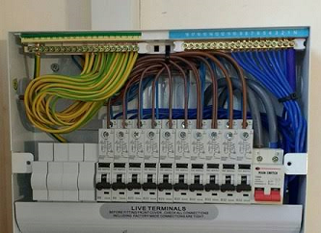

* Pole Erection , stringing and transformer

Installation.

* Generator & ATS installation and maintenance,
* Building electrical Design and installation.

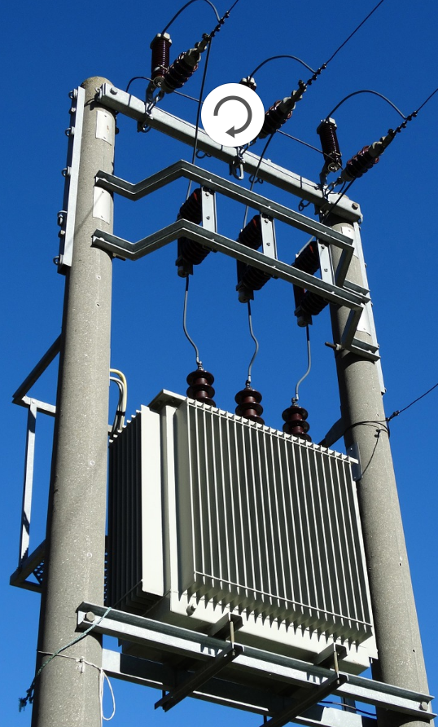

* Maintenance building electrical installation.
* Industrial electrical installation.
* Power Board and UPS installation.
* CCTV camera, fire alarm, security camera Design and

Installation and Access control.

* Building network installation like patch panel,

Hub and switch.

* Control system and Maintenance for motors

and generators.

* Drive Test for single sites (SSV), Cluster test

and Optimization

## Electromechanical work:

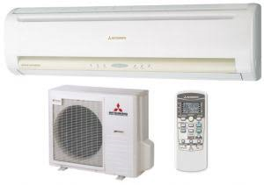

* Air conditioner installation and its maintenance.
* Street light installation.
* Machine installation and its maintenance.
* Sanitary.
* Aluminum partition.
* Solar power installation.

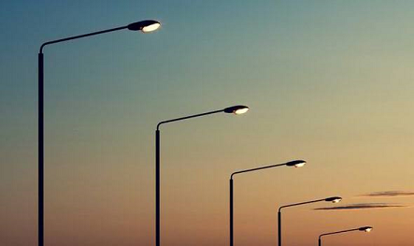

* Piping work.
* Tanker installation.

# Objectives

The main objectives of the company are to focus its activities toward the more specialized services and become a leader in the profession.

Our objectives include among others:

## For individual (owners)

* Generates sufficient cash flow to finance future growth and development and to provide the resource needed to achieve the other objectives of the company.
* Expand the business at rate that is both challenging and manageable serving the market with innovation and adaptability.
* To produce innovative and communicative individual.
* The objective of the company are to generates a profit grow at a challenging and manageable rate and to be a good citizen

## For society and government

* To facilitate any organization have well designed installation.
  + - To be intellectual and social asset to be community and government.
    - To create job opportunity for community.
    - To minimize unnecessary wastage
    - To get better service with fair price.
    - Avoiding monopolized market.
    - Per capital increase and increasing income tax.
    - Improvement of technology.
    - Saving foreign currency

# Completed and work on progress of the company



## Completed work

* Pole erection, Transformer mount and cable stringing for MV (medium voltage) projects of **POWER CHINA** with **KAZA engineering**
* For City government of Addis Ababa saving house development enterprise (40/60 condominium) G+10 two blocks in Ayat site building electrical installation with **Afwork Gidey General Contractor**.
* Data center electrical installation work, data outlet, Tel outlet, AC, UPS, fire alarm system and Generator installations with **IE network solution** in **Wolo university project.**
* Data Center electrical installation work, data outlet, Tel outlet, AC, UPS, fire alarm system and Generator installations with **IE network solution** in OFAG (Federal auditor) project.
* G+6 building Data, Tele and fire alarm system work at Arbamichi university Abaya campus with **TNT construction and trading.**
* G+2 building Data, Tele and fire alarm system work at Arbamichi university Chamo campus with **TNT construction and trading**
* **G+4 building** Data and Tele system work at chiro finance office project with **HAKICON ENGINEERING PLC.**
* **AC work (Air conditioner) at mojo, Debreziyit, Dukem and Ginchi substation with TNT construction and trading**
* Finishing works, screed, Marble, ceramic, riser and trade works with **Kidber Construction.**

## Current progress of the company

* Ethiopia new Telecom license power access project **POLE ERECTION , TRANSFORMER MOUNT , CABLE STRINGING……** work with **ZTE(H.K)** Limited Ethiopia branch company.
* For City government of Addis Ababa saving house development enterprise (40/60 condominium) G+10 two blocks in Ayat site building electrical installation with **Kidber construction.**
* 2- Basement+Ground+Mizani+17 floor Grace Hotel electrical works with **RBM construction.**
* For Addis Ababa university science and technology G+4 commercial building Data, fire alarm, CCTV, camera and public address system work with **TNT construction and trading.**
* Entoto secondary school G+4 office building Data, fire alarm, CCTV, camera and public address system work with **TNT construction and trading.**
* **G+4** two blocks data and Tele system work at **chiro university** project with **TNT construction and trading**.
* **Electrical work G+7 building Kolfe Keraniyo sub city with Merab construction.**
* **Ambo university Administration** G+4 building Data and Tele system work with **TNT construction and trading**

# COMPANY STRUCTURE

General Manager

MECHANIC TECHNICIANS

ELECTRICIANS

MECHANICAL SUPERVISOR

ELECTRICAL SUPERVISOR

DEPUTY & PROJECTS MANAGER

FINANCE AND TECHNICAL MANAGER

# STAFF LIST OF THE COMPANY

|  |  |  |  |  |
| --- | --- | --- | --- | --- |
| no | Name | sex | qualification | Job Title |
| Owner of the company | | | | |
| 1 | Teklay Haile | M | BSC(Electrical Engineering), MBA(Master in Business Administration ) | General Manger |
| 2 | ZekariasDamtew | M | BSC(Electrical Engineering), MAPM(master in Project management) | Deputy and Projects Manager |
| 3 | YohanessTolossa | M | BSC(Electrical Engineering), MSC(Master in Power Engineering ) | Finance & Technical manger |
| Contractual staff | | | | |
| 4 | HintsaHailu | M | BSC(Electrical Engineering) | Electrical supervisor |
| 5 | Fistum Belete | M | BSC(Mechanical Engineering) | Mechanical supervisor |
| 6 | AddisuTamir | M | BSC(Electrical Engineering) | Electrician |
| 7 | SeidYimer | M | Industrial machine &drive L 3 | Electrician |
| 8 | Berhane Bitweded | M | 10+2 Electricity | Electrician |
| 9 | Tamrukidane | M | Electrical Installation | Electrician |
| 10 | G/selase G/Mariam | M | 10+2 Electricity | Electrician |
| 11 | Chrenet T/hayimanot | M | 10+3 Electricity | Electrician |
| 12 | GetnetMekonent | M | 10+3 Electricity | Electrician |
| 13 | Simon zeru | M | 10+3 Electricity | Electrician |
| 14 | TeferaAbebe | M | 10+3 Electricity | Electrician |
| 15 | TelahunTeshome | M | General metal Fabrication & assembly | Mechanics |

# WORK EXPERIENCE OWNER OF THE COMPANY

## TEKLAY HAILE (General Manager)

* As a position of **project supervisor/ drive test engineer** in **I engineering group SAL branch** of Ethiopia, at **Ericsson** and **ZTE projects**.
* As **Derive test Engineer** in**Huawei Company**.
* As **site engineer** in **GTC Global Telecom Company** in **Ericsson Project**.
* As **site and drive test Engineer in** Axumic technology PLC, at **Huawei project**.
* During campus period final project industrial installation and rehabilitation at Bruhtesfa irrigation and a water technology.
* During campus period mini project in industrial installation at Mesfin industrial engineering
* Internship project UPS design.
* Oct, 2005-feb, 2005 internship program in Moha soft drinks industry.

## ZEKARIAS DAMTEW (Technical Manager)

* AS **Derive test engineer in Huawei Company** in different region.
* AS**Derive test in Huawei** by local subcontract company **Axumic technology**.
* AS **SITE ENGINEER in Ericson** by subcontract company global Telecom construction(**GTC**)
* Oct, 2005-feb, 2005 internship program in Moha soft drinks industry..
* During campus period mini project in industrial installation at Mesfin industrial engineering
* During campus period final project industrial installation and rehabilitation at bruh tesfairrigation and a water technology

## YOHANNES TOLOSSA (Finance Manager)

* AS **GROUND TECHICIAN**, at **ETHIOPIA AIRLINES**.
* As **site supervisor** in Axumic Technology PLC, in **Meta Abo project**.
* During campus period final project industrial installation and rehabilitation at bruhtesfairrigation and a water technology.

# Document and Recommendation paper of the company







